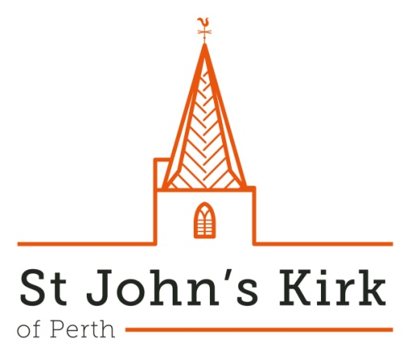

***St John’s Music***

**Season 2025-26**

**St John’s Kirk is one of Perth’s oldest and most beautiful buildings and has stood as a place of regular worship at the very heart of the Fair City for over eight hundred years.**

**With a fine three-manual organ and a wonderful acoustic it is also loved by performers and audiences alike as a focal point for music.**

**(The programme details overleaf are correct as of August 2025 but are always subject to change).**

Sat 4 Oct 2025, 1.00 pm

**Jack Oades (organ)**

Sun 19 Oct 2025, 3.00 pm

**Tayside Big Band**

Sat 1 Nov 2025, 1.00 pm

**Chris Nickol (organ)**

*Sun 16 Nov 2024, 3.00 pm*

**\*Resol String Quartet\***

Sat 6 Dec 2025, 1.00 pm

**The 4 Cellos**

Sun 14 Dec 2025, 3.00 pm

**Perthshire Brass** with **Scottish Police and Community Choir**

*Sun 18 Jan 2026, 3.00 pm*

**\*Liam Bonthrone (tenor) and Benjamin Mead (piano)\***

Sat 7 Feb 2026, 1.00 pm

**Laurent Jochum (organ)**

*Sun 8 February 2026, 3.00 pm*

**\*Dudok String Quartet\***

Sat 7 March 2026, 1.00 pm

**Ischico Veizel (piano)**

*\*denotes event promoted by Perth Chamber Music but taking place at customary St John’s Music time (NB: paid admission required)*

**St John’s Music**, running throughout autumn, winter and early spring, is a series of Organ and Chamber Recitals (usually on the first Saturday of the month at 1.00 pm) and Concerts (occasional Sundays at 3.00 pm) promoted by the Kirk. It aims to showcase the best of local music-making and to provide a platform for the many talented performers who live in and around Perthshire as well as other musical friends from further afield.

In addition the Kirk often plays host to professional ensembles within Scotland (Dunedin Consort, Scottish Ensemble, etc), Perth Chamber Music Society and a wealth of internationally renowned soloists, as well as amateur choirs and ensembles from the region.

If you would like to be kept informed of musical events at St John’s you can join our e-mailing list by submitting your e-mail address via the Contact menu of our website, which also contains full details for all concerts and recitals:

www.st-johns-kirk.co.uk

*Free admission (retiring collection) at all events except those marked* (details at* *www.perthchambermusic.org.uk**)*